Thursday, September 04, 2025
To: [Manager name]
From: [Your name]
Re: American Society of Safety Professionals Education Event: SafetyFOCUS
I am requesting approval to attend the American Society of Safety Professionals (ASSP) Education Event SafetyFOCUS the week of February 9-13, 2026.
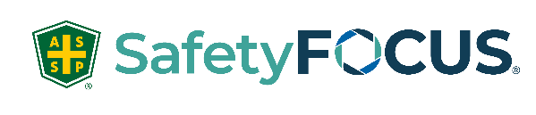

SafetyFOCUS is the place for safety professionals to gain in-depth training on important safety topics. Courses are taught virtually via Zoom by leading safety experts who will engage learners through thoughtful discussion, new perspectives and proven strategies. This is an excellent opportunity for me to focus on key areas and collaborate with other safety professionals so I can elevate our Safety Programs and meet our company objectives. Plus, I will be able to earn IACET-accredited continuing education units (CEUs) to maintain my safety certification. This one-of-a-kind event is exactly what I need to further my knowledge and bring new and innovative solutions back to my team.
My attendance will be a cost-effective investment for the company and an invaluable experience as a safety professional. I’ve attached a comprehensive course list of topics that I feel will make the most impact upon my completion. I also intend to share best practices and lessons learned so others can benefit from my experience as well. Here’s an approximate breakdown of costs:
Courses: $ [check for current price]
Total: $
My goal is to constantly grow as an individual and I strive to become a more proficient and effective safety professional. I hope you agree that my professional development and increased safety knowledge is a worthwhile investment to our organization.
More information about SafetyFOCUS can be found at SafetyFOCUS.assp.org. Additionally, if we send a team of 5 or more, we can take advantage of discounted group rates up to 20%. The sooner we register, the better the savings!

Thank you for your consideration, and I look forward to your reply.

(Insert name here)

