Sunday, July 24, 2022
To: [Manager name]
From: [Your name]
Re: American Society of Safety Professionals Education Event: SafetyFOCUS
I am requesting approval to attend the American Society of Safety Professionals (ASSP) Education Event SafetyFOCUS October 24 – October 28, 2022.
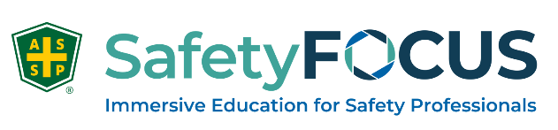

SafetyFOCUS features immersive safety courses taught by world class industry experts and engages learners in the most relevant topics affecting safety today. This is an excellent opportunity for me to focus on key areas to make an impact into our Safety Programs to meet our company objectives. Plus, I will be able to earn IACET-accredited continuing education units (CEUs) to maintain my safety certification. This one-of-a-kind event is exactly what I need to further my knowledge and to bring back new and innovative solutions back to my team.
My attendance will be a cost-effective investment for the company and an invaluable experience as a safety professional. I’ve attached a comprehensive course list of topics that I feel will make the most impact upon my return. I also intend to share best practices and lessons learned so others can benefit from my experience as well. Here’s an approximate breakdown of costs:
Airfare: $
Transportation (between airport and hotel): $
Hotel: $
Meals: $
Courses: $ [check for current price]
Total: $

My goal is to constantly grow as an individual and I strive to become a more proficient and effective safety professional. I hope you agree that my professional development and increased safety knowledge is a worthwhile investment to our organization.
More information about SafetyFOCUS can be found at SafetyFOCUS.assp.org. Additionally, if we send a team of 5 or more, we can take advantage of discounted group rates up to 20%. The sooner we register, the better the savings!

Thank you for your consideration, and I look forward to your reply.

(Insert name here)

